Paaresha Sharma 

About:

“Ambitious you are but ambit restricts” Paareshala blog is introduced to push behind the horizons of fashion, lifestyle and travel.

Paaresha Sharma a full-time blogger and a model featuring and promoting fashion, lifestyle, travel and food across the World in all ethnicity and culture.

Paaresha with her immense sense of styling has built a great following of friends who loves fashion, food and travel.

Readers follow Paareshala for latest fashion trends, hot brands and a trending style for different occasions.

She has also worked with several Indian daily soaps on Star Plus, web series by Kabir Khan and Laughing Colors, short films, music video with Luv Tyagi and a digital ad with Evara.

Collaborations:

Paaresha offers the variety of affordable services for marketing your brand which includes but not limited to:

* Social Promotion
* Product Review
* Sponsored Post
* Giveaway
* Multi Brand Collaboration
* Spokesmodel
* Brand Ambassador

We kick of each partnership with survey and strategic release plans for maximum outreach and then engage our subscribers with digital editorial and social media content to further tell the story of the brands and their services.

Associations:

Paaresha offers the variety of affordable services for marketing your brand which includes but not limited to:

    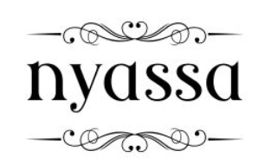

     

    

     

    

  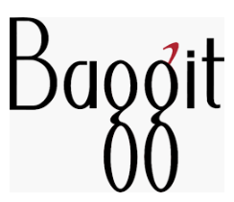   

     

    

   

Contact:

PhotograpH

For Collaborations, booking enquiries or anything related to shoot.

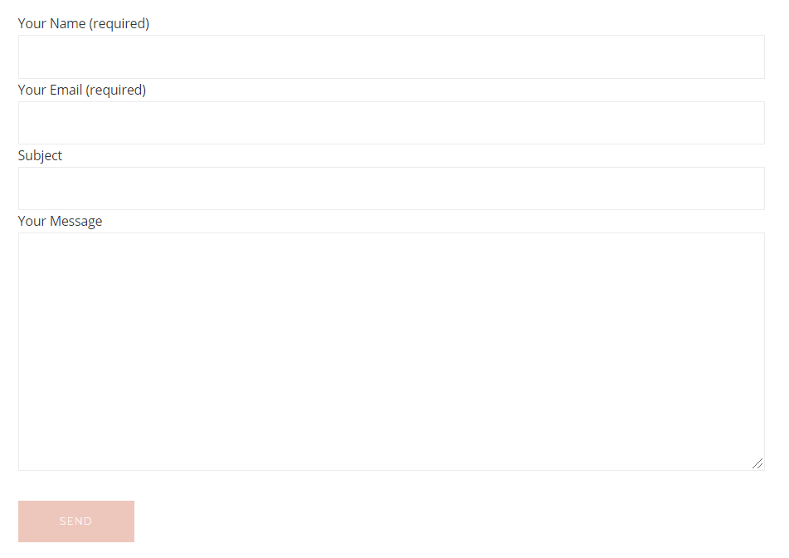

Be passionate enough to follow your dreams.

Drop me an email at [paaresharma@gmail.com](mailto:paaresharma@gmail.com)

Photograph 4

Photograph 3

Photograph 2

Photograph 1

Footer:

Paaresha Sharma

Quick Links

[Sidebar Title]

[Sidebars are great for calling out important points from your text or adding additional info for quick reference, such as a schedule.

They are typically placed on the left, right, top or bottom of the page. But you can easily drag them to any position you prefer.

When you’re ready to add your content, just click here and start typing.]

Q



* About
* Collaborations
* Contact